PRESS RELEASE – 3rd December 2013
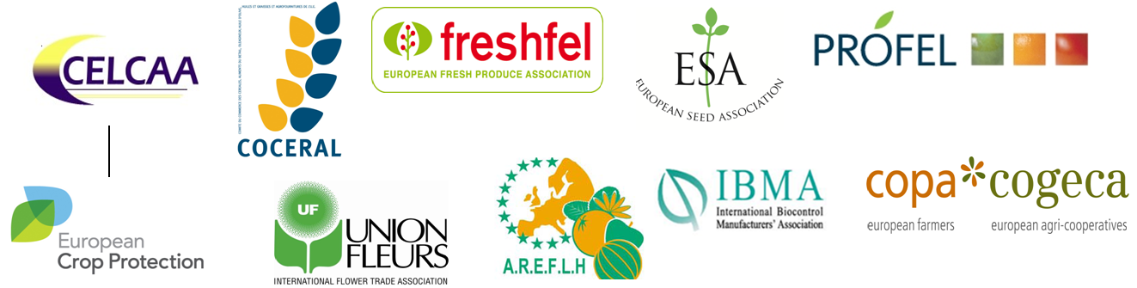
Brussels 3 December
Crop diversity, food safety and food security under threat in Europe
THE AGRI-FOOD CHAIN WELCOMES THE EU COMMISSION’S COMMITTMENT TO SET UP AN EU PLATFORM FOR MINOR USES AND SPECIALTY CROPS, AND CALLS FOR IMMEDIATE ACTION TO ADDRESS THE LACK OF PLANT PROTECTION PRODUCTS IN THIS AREA
Europe needs to do more to improve the availability of tailor-made plant-protection solutions for minor uses and specialty crops, participants confirmed at a major conference held in European Parliament today.
The event, hosted by MEP Paolo de Castro, Chairman of the Agriculture and Rural Development Committee (COMAGRI) at the European Parliament, focused on concrete solutions and investment schemes needed to support minor uses and specialty crops and to improve the availability of tailor made solutions for their protection.
On this occasion, the European Commission announced that the report on minor uses and specialty crops will be published in early 2014, after two years of delay. “The continuous delay in publishing this report is certainly not encouraging for European agriculture, but today’s commitment of the European Commission is a good step forward” said Jean-Charles Bocquet, Director General of European Crop Protection Association (ECPA).
“The minor use and specialty crops sector is of huge importance in Europe, representing €70 billion per year, and 22% of the total output value of the agricultural sector. Solutions are needed to ensure the competitiveness of the entire agri-food chain and high quality products for European consumers” said Paolo De Castro, COMAGRI Chair.
The participants agreed that the reduction in plant protection solutions cannot be ignored any longer given upcoming challenges like food security in Europe and worldwide, the need of high quality food products at an affordable price for consumers, and to ensure the competitiveness of the whole agri-food chain.
“The lack of proper tools compromises not only the competitiveness of the entire agri-food chain – the EU being the second largest producer of fruit and vegetables in the world and also the second largest importer – but it also compromises the sustainability of the sector, the employment generated within the sector, and more importantly the diversity high quality agri-food products in Europe”, said Luc Peeters Chairman of COPA-COGECA’s Working Party on Phytosanitary Questions, on behalf of the 10 agri-food chain associations.
He continued “In order to effectively find plant protection solutions, we need an ambitious approach aimed at setting up a permanent EU programme for minor uses and speciality crops, and coordinated across all twenty-eight Member States with a coherent funding programme for data generation and the development of new solutions” .
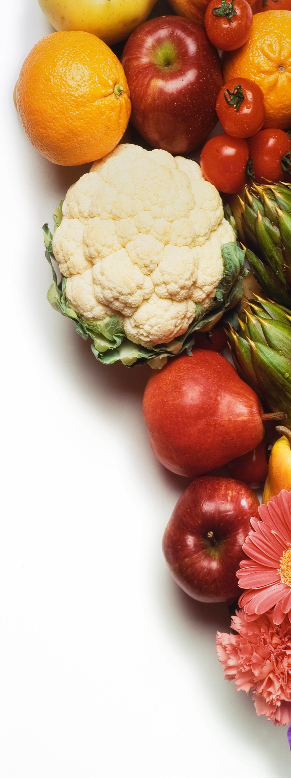
Note:
Minor uses concern fruit and vegetables, cereals, including rice, seeds, hops, flowers and all those plants that need a tailor made plant protection product, whether it is for growing them, storage or transportation.
Speciality crops are valued at about €70 billion per year, representing 22% of the total output value of the agricultural sector . The fruit and vegetable sector alone accounts for about €45 billion in EU-27 for a total production of 70 million tons of vegetables and 40 million tons of fruits. The market value for ornamental plants is estimated at €27 billion.

CONTACT DETAILS
AREFLH Assemblée des Régions Européennes Fruitières, Légumières et Horticoles www.areflf.com
Jacques Dasque
areflh@aquitaine.fr
+33 556 48 88 48

COCERAL Comité du Commerce des céréales, aliments du bétail, oléagineux, huile d'olive, huiles et graisses et agrofournitures www.coceral.com
Andreea Pricina
secretariat@coceral.com
+32 (0)2 502 08 08

ECPA European Crop Protection Association www.ecpa.eu
Euros Jones
Euros.jones@ecpa.eu
+32 (2) 663 15 53
FRESHFEL European Fresh Produce Association www.freshfel.org
Frédéric Rosseneu
info@freshfel.org
+32 (0)2 777 15 80

ESA European Seed Association www.euroseeds.org
Garlich von Essen
vonEssen@euroseeds.org
+32 (0)2 743 28 60

COPA-COGECA European Farmers and European Agri-Cooperatives www.copa-cogeca.eu
Pasquale Di Rubbo
Pasquale.DiRubbo@copa-cogeca.eu
+ 32 (0)2 287 27 45

Amanda Cheesley
Amanda.cheesley@copa-cogeca.eu
+32 (0) 2 287 27 90

PROFEL European Association of Fruit and Vegetable Processors www.profel-europe.eu
Silvia Selandari
sselandari@agep.eu
+32 2 740 29 68
IBMA International Biocontrol Manufacturers Association www.ibma-global.org
David Cary
david.cary@ibma-global.org
+44 777 551 48 40

Union Fleurs International Flower Trade Association www.unionfleurs.org
Sylvie Mamias
secgen@unionfleurs.org
+32 2 231 06 38

The 10 agri-food chain associations are AREFLH, CELCAA, COCERAL, COPA-COGECA, ECPA, ESA, Freshfel, IBMA, PROFEL, Union Fleurs.

