PRESS RELEASE – 19th May 2014
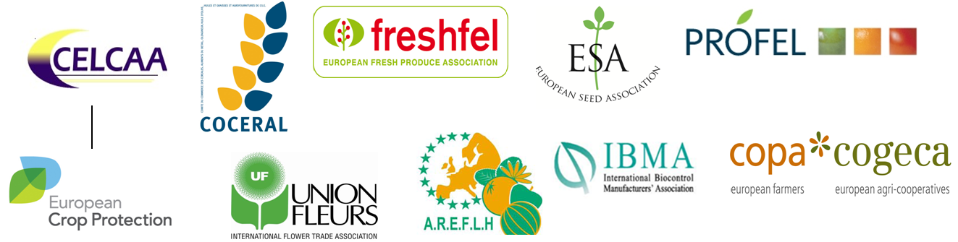

Crop protection solutions urgently needed in the EU to preserve safety and diversity of agri-food products
Agri-food chain coalition calls for a more ambitious EU approach on minor uses and specialty crops
A broad coalition of associations representing Europe’s agriculture and food chain industries calls on the EU to do much more to find solutions to the lack of plant protection products for specialty crops, such as fruits and vegetables, rice, flowers or seeds. In February 2014 the European Commission (DG SANCO) published a long awaited report on the establishment of a European fund for these so-called minor uses products. The agri-food chain associations agree that the proposal does not go far enough, leaving many problems still unresolved.

The proposed platform at EU level for coordination of existing activities on minor uses and specialty crops via a secretariat is certainly a good start, but it does not offer a long-term perspective.
“The lack of proper plant protection solutions compromises not only the competitiveness of the entire agri-food chain – the EU being the second largest producer of fruit and vegetables in the world and also the second largest importer – but it also compromises the sustainability of the sector to prevent and control new emerging pests, the employment generated within the sector, and more importantly the diversity of high quality agri-food products in Europe”, said Pekka Pesonen, COPA-COGECA Secretary General on behalf of the agri-food chain partners.
“These may be referred to as “minor crops”, but they are of major importance to the European economy, and to consumers,” said Jean-Charles Bocquet, Director General of the European Crop Protection Association. “To better provide plant protection solutions, we need not only more coordination but also a mechanism in place for boosting cooperation and part funding of research projects. Only in this way will we address all problems by leveraging common solutions for all minor uses and specialty crops in a cost effective manner. Otherwise we will continue to learn about problems from one another and not have solutions available to address them.”
“Solutions need to be urgently found to make mutual recognition of plant protection products across EU Member States really possible for specialty crops for all the agri-food chain actors, including producers and industrial processors” said Jean Bernard Bonduelle - PROFEL President
The agri-food chain partners propose a more permanent programme on minor uses and specialty crops to be developed within a smart, sustainable and inclusive growth policy in line with Europe 2020 objectives. Such a programme should provide funding to support and boost initiatives to find minor use solutions. A similar programme is already in place in the USA, and for each dollar spent on that programme, it has been calculated that there is an economic benefit of $500 (Annual spending of $14 million providing an annual economic benefit of $7.7 billion).
Notes to editor:
Minor uses concern fruit and vegetables, cereals, including rice, seeds, hops, flowers and all those plants that need a tailor made plant protection product, whether it is for breeding or growing them, storage or transportation.

This minor use and specialty sector is of huge importance in Europe; it represents 18% of the agricultural value on just 3% of the land. The EU is the second largest producer of fruit and vegetables in the world with value exceeding €70 billion per year; and it is also the second largest importer.

The EU’s stringent regulatory process for plant protection products has had an especially severe impact on the availability of products for specialty crops and minor uses. There is a need to review by December 2014 the Regulation 1107/2009 on the authorization of plant protection products in the EU while complying with the high safety legal requirements.
Under its 7th Framework Programme for research, the European Commission will support an ERANET on Integrated Pest Management with specific reference to minor uses (IPM ERANET). This additional instrument of coordination of public research funded by EU Member States is certainly welcome. But it will be important that the work plan of the ERANET is strongly linked to the gaps and needs of solutions identified by the coordination platform on minor uses and specialty crops. At the moment it appears these two initiatives are not well connected to each other, and that the ERANET does not take stock of what is already available in terms of gaps of plant protection identified so far, while moving rapidly forward to the second step, which is financing of new solutions.

CONTACT DETAILS
AREFLH Assemblée des Régions Européennes Fruitières, Légumières et Horticoles www.areflf.com
Jacques Dasque
areflh@aquitaine.fr
+33 556 48 88 48

COCERAL Comité du Commerce des céréales, aliments du bétail, oléagineux, huile d'olive, huiles et graisses et agrofournitures www.coceral.com
Andreea Pricina
secretariat@coceral.com
+32 (0)2 502 08 08

ECPA European Crop Protection Association www.ecpa.eu
Euros Jones
Euros.jones@ecpa.eu
+32 (2) 663 15 53
FRESHFEL European Fresh Produce Association www.freshfel.org
Frédéric Rosseneu
info@freshfel.org
+32 (0)2 777 15 80

ESA European Seed Association www.euroseeds.org
Amalia Kafka AmaliaKafka@euroseeds.org
+32 2 743 28 60

COPA-COGECA European Farmers and European Agri-Cooperatives www.copa-cogeca.eu
Pasquale Di Rubbo
Pasquale.DiRubbo@copa-cogeca.eu
+ 32 (0)2 287 27 45

Amanda Cheesley
Amanda.cheesley@copa-cogeca.eu
+32 (0) 2 287 27 90

PROFEL European Association of Fruit and Vegetable Processors www.profel-europe.eu
Silvia Selandari
sselandari@agep.eu
+32 2 740 29 68
IBMA International Biocontrol Manufacturers Association www.ibma-global.org
David Cary
david.cary@ibma-global.org
+44 777 551 48 40

Union Fleurs International Flower Trade Association www.unionfleurs.org
Sylvie Mamias
secgen@unionfleurs.org
+32 2 231 06 38

